Name : niya dodiya

Roll no:2199

Fa2

Java assignment 3(unit-2)

1.oreder details

// package as3;

// 2199 niya dodiya

abstract class order {

    protected int orderid;

    public String productname;

    protected double quantity;

    protected double price;

    order(int orderid,String productname,double quantity,double price){

        this.orderid=orderid;

        this.productname=productname;

        this.quantity=quantity;

        this.price=price;

    }

    abstract void displayorderdetails();

}

abstract class  payment{

    protected double amount;

    payment(double amount){

        this.amount=amount;

    }

    abstract void processpyment();

}

class paypalpayment extends order{

        paypalpayment(int orderid,String productname,double quantity,double price){

            super(orderid, productname, quantity, price);}

//            System.out.println("succesfully payment in paypal");

            void displayorderdetails() {

                //TODO Auto-generated method stub

                 System.out.println("ORDER ID "+orderid+" PRODUCT NAME "+productname+" QUANTITY "+quantity+" PRICE "+price);

            }

}

class creditcard extends payment{

    //creditcard(int orderid,String productname,double quantity,double price){

        creditcard(double amount){

            super(amount);

        }

      //  System.out.println("succesfully payment in creditcard");

        void processpyment(){

            System.out.println("payment of ammount "+amount+" processed using creditcard");

        }

  }

public class PAYMENTAPP{

    public static void main(String[] args) {

        System.out.println("2199 : niya dodiya");

        order a1=new paypalpayment(101,"exyz",2000,125463.52);

        a1.displayorderdetails();

        payment p1=new creditcard(50000);

        p1.processpyment();

    }

}

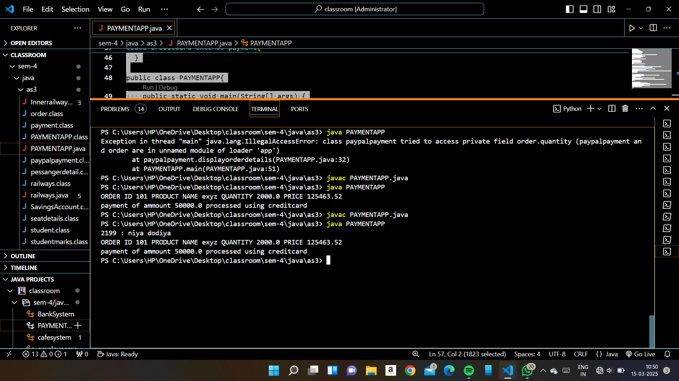

2.cafemanagment system

// 2199 niya doiya

// package as3;

/\*multilevel inharitance and method overloadding \*/

class cafe{

     protected String cafename,location;

    cafe(String cafename,String location){

        this.cafename=cafename;

        this.location=location;

    }

    void showdetails(){

        System.out.println(cafename);

        System.out.println(location);

    }

 }

class menu extends cafe{

     protected String itemname;

     protected double price;

     menu(String cafename,String location,String itemname,double price){

        super(cafename, location);

        this.itemname=itemname;

        this.price=price;

     }

     void showdetails(){

        super.showdetails();

        System.out.println(itemname);

        System.out.println(price);

    }

}

class order1 extends menu{

    private  String customername;

    private int quantity;

    protected double totalammount;

    order1(String cafename,String location,String itemname,double price,String customername,int quantity){

        super(cafename, location, itemname, price);

        this.customername=customername;

        this.quantity=quantity;

        this.totalammount=price\*quantity;

    }

    void showdetails(){

        super.showdetails();

        System.out.println(customername);

        System.out.println(quantity);

        System.out.println(totalammount);

    }

}

public class cafesystem{

    public static void main(String[] args) {

        System.out.println("2199 : niya dodiya");

        order1 o1=new order1("LEELA'S CAFE ", "AHEMDABD", "COFE", 150, "RITA SHAH",2);

        o1.showdetails();

    }

}

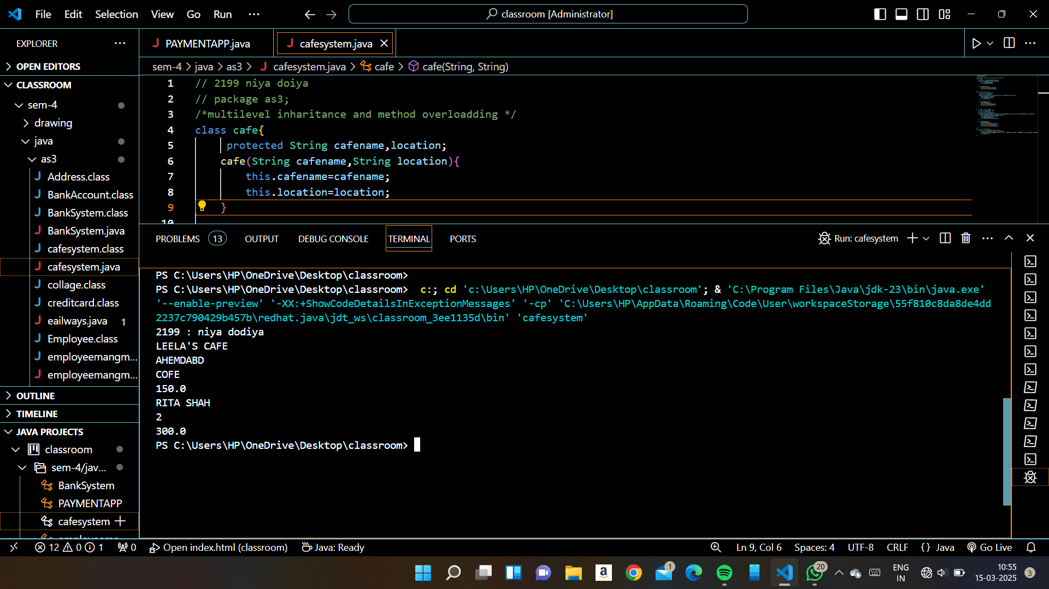

// package as3;

3.railway management system

/\*multiplae inharitance and interafce \*/

interface tradetails{

    void showtraininfo();

}

interface pessangerdetail{

    void passengetinfo();

}

interface seatdetails{

    void seatinfo();

}

class ticketbokking implements tradetails,pessangerdetail,seatdetails{

    protected String trainname="VANDE BHARAT";

    private int trainno=1203461;

    protected String passangername;

    protected int age;

    public int seatno;

    public String seatype;

    private double ticketprice;

    ticketbokking(String passangername,int age,int seatno,String seattype){

        this.passangername=passangername;

        this.age=age;

        this.seatno=seatno;

        this.seatype=seattype;

        if(seattype.equals("AC"))

        ticketprice=1000;

        else

        ticketprice=500;

        //this.ticketprice=ticketprice;

    }

    public void showtraininfo(){

        System.out.println(trainname+" "+trainno);

    }

    public void passengetinfo(){

        System.out.println(passangername+" "+age);

    }

    public void seatinfo(){

        System.out.println(seatno+" "+seatype+" "+ticketprice);

    }

}

public class railways{

    public static void main(String[] args) {

        System.out.println("2199 : niya dodiya");

        ticketbokking t1=new ticketbokking("niya",20,1265,"NON-AC");

        t1.showtraininfo();

        t1.passengetinfo();

        t1.seatinfo();

    }

}

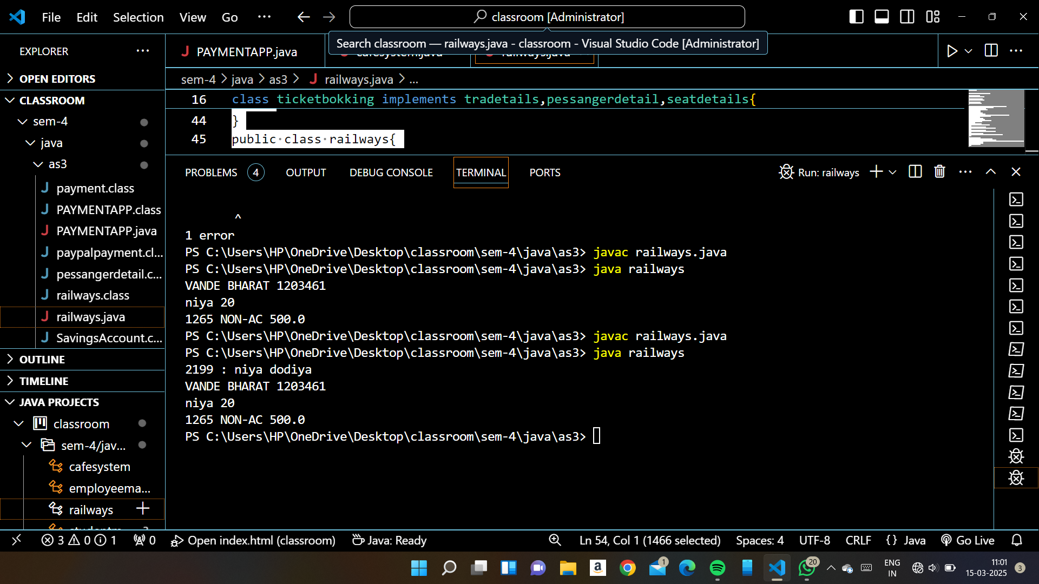

4.collage management system

//package as3;

/\* hyriarchical inharitance \*/

class collage{

    protected String clgname="ks";

    private  int clgcode=01;

    void displayclginfo(){

        System.out.println("collage name:" +clgname);

        System.out.println("collage code: "+clgcode);

    }

}

class student extends collage{

     private int marks[] ={88,54,98};

     int total;

     protected char grade;

     void calculatetotalmarks(){

        for(int mark:marks){

            total+=mark;

        }

     }

     void calculategrade(){

        grade=total/3 >= 85 ? 'A' : 'B';

     }

     void displayinfo(){

        displayclginfo();

        calculatetotalmarks();

        calculategrade();

        System.out.println("total marks:"+total);

        System.out.println("Grade: "+grade);

     }

}

public class studentmarks{

    public static void main(String[] args) {

        System.out.println("2199: niya dodiya");

        student s1=new student();

        s1.displayinfo();

    }

}

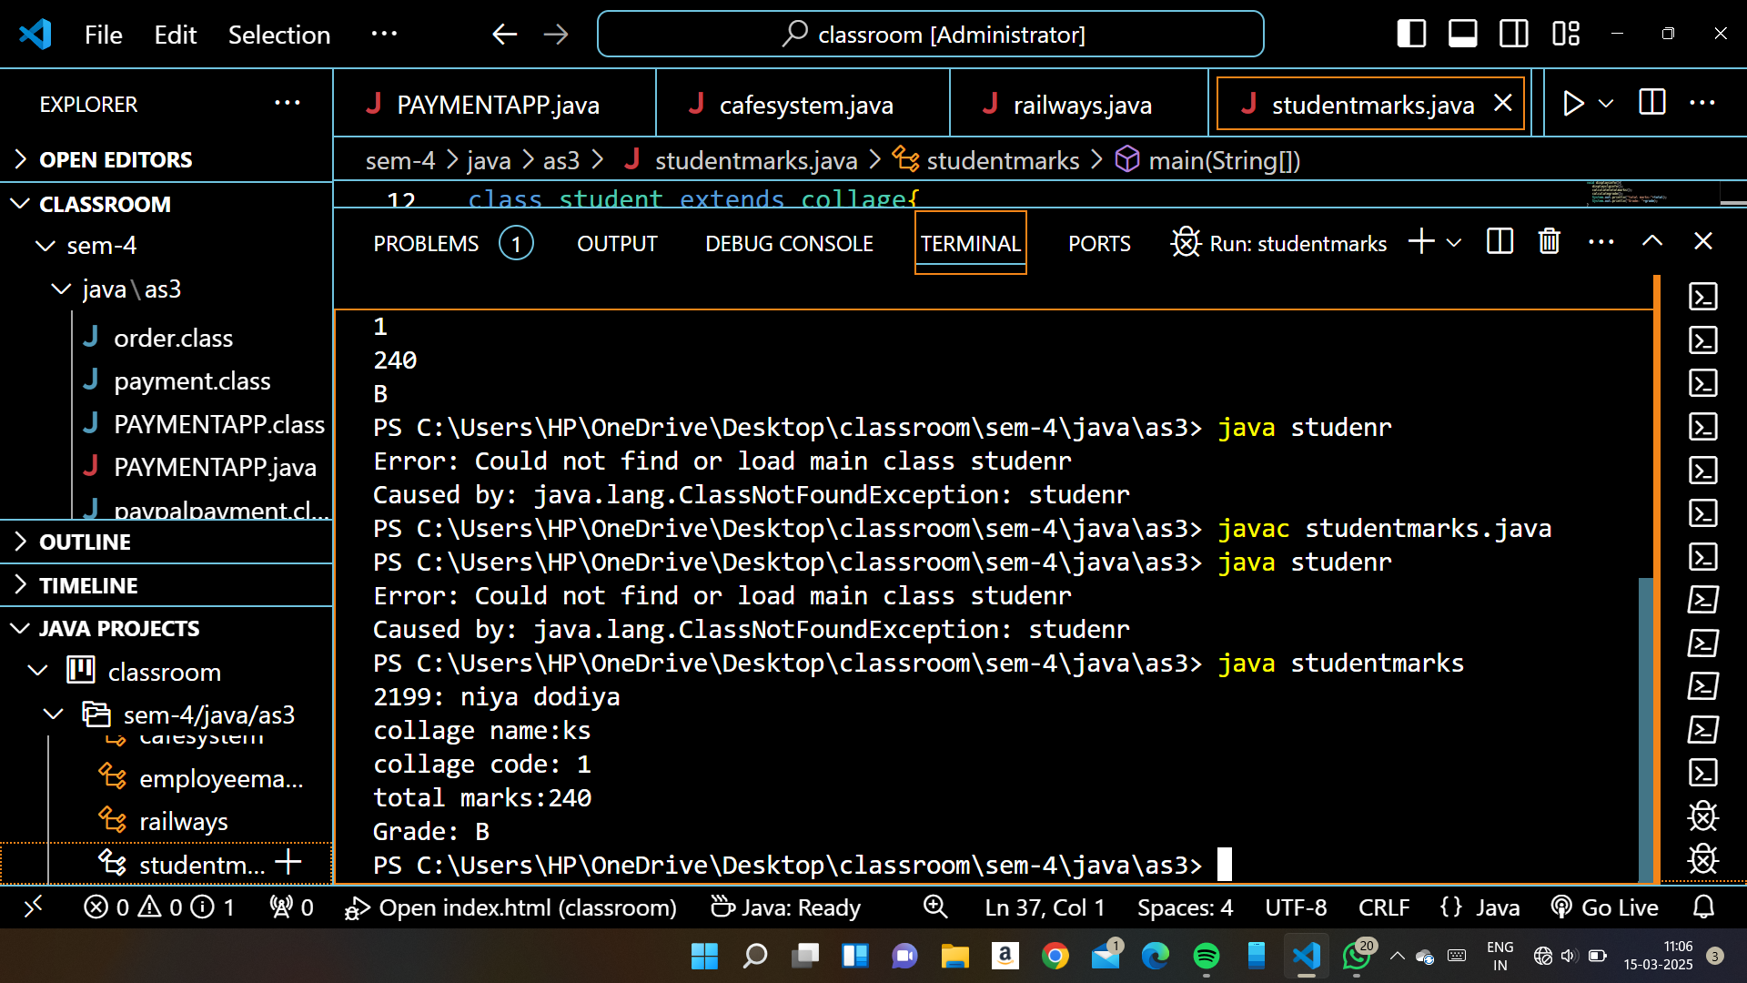

//package as3;

5.bank management sysytem

/\*abstract class methos overriding \*/

abstract class BankAccount {

    protected int accountNumber;

    public String accountHolderName;

    protected double balance;

    BankAccount(int accountNumber, String accountHolderName, double balance) {

        this.accountNumber = accountNumber;

        this.accountHolderName = accountHolderName;

        this.balance = balance;

    }

    abstract void withdraw(double amount);

    void deposit(double amount) {

        balance += amount;

    }

    void displayAccountDetails() {

        System.out.println("account holder id:" +accountNumber+"  ,Account Holder name: " + accountHolderName + ", Balance: " + balance);

    }

    // abstract method

    // abstract void withdraw(double amount);

}

class SavingsAccount extends BankAccount {

    private double interestRate;

    public SavingsAccount(int accountNumber, String accountHolderName, double balance,double interestRate) {

        super(accountNumber, accountHolderName, balance);

        this.interestRate=interestRate;

    }

    void withdraw(double amount) {

        if (balance - amount >= 500) {

            balance -= amount;

        System.out.println("afther withdraw: "+balance);

        }

        else {

            System.out.println("Insufficient Balance");

        }

        }

}

public class BankSystem {

    public static void main(String[] args) {

        System.out.println("2199 :niya dodiya");

        SavingsAccount acc = new SavingsAccount(12345, "John Doe", 2000,5);

        acc.displayAccountDetails();

        acc.withdraw(500);

    }

}

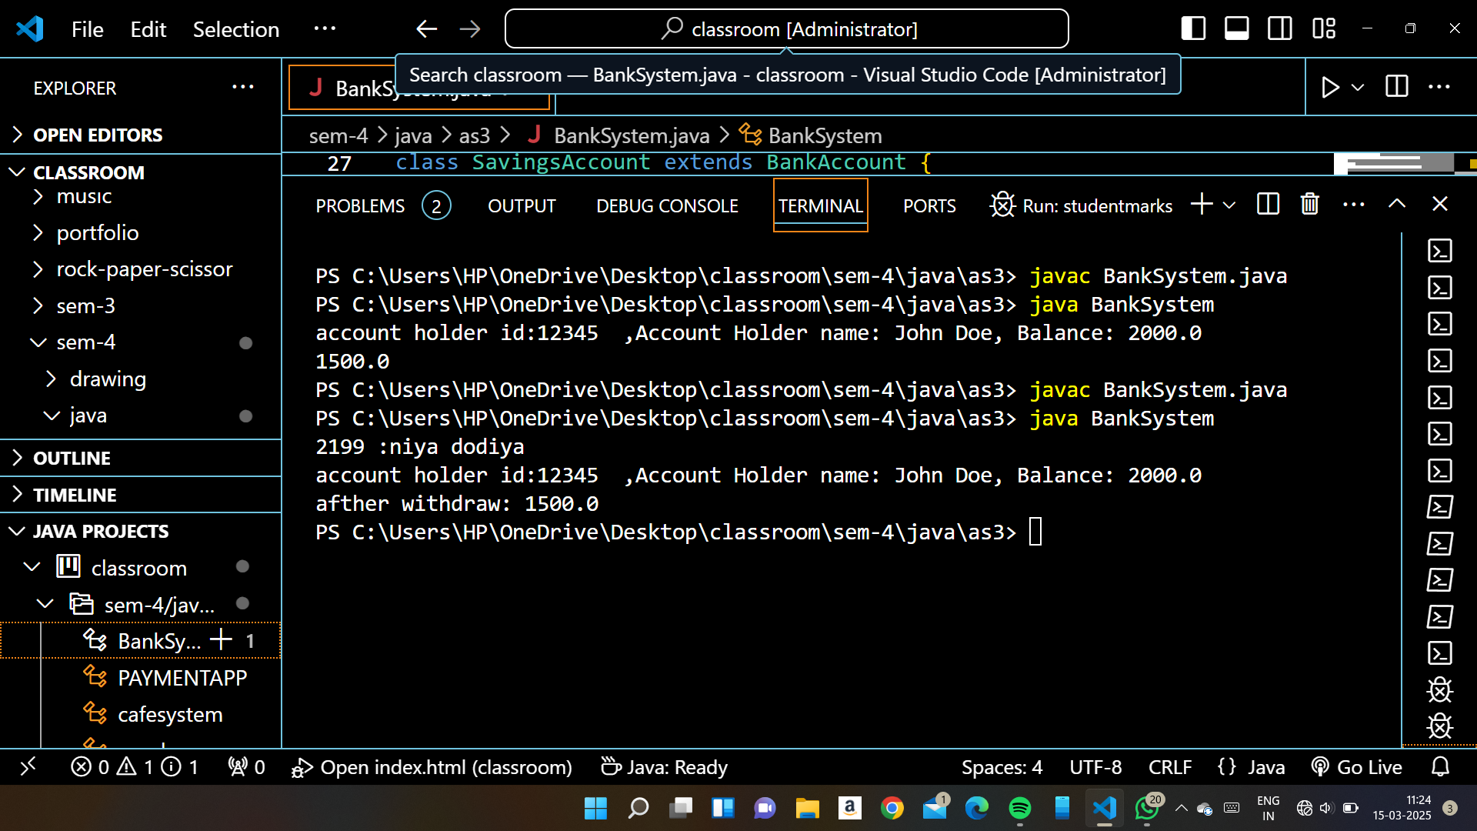

//package as3;

6.employee management system

/\*multilevel inharitance \*/

class Address{

    String city,state,country;

    Address(String city,String state,String country){

        this.city=city;

        this.state=state;

        this.country=country;

    }

}

class student{

    protected int sid;

    public String sname;

    student(int sid,String sname){

        this.sid=sid;

        this.sname=sname;

    }

}

// address and employye have in a has a relationship

class Employee extends student{

    protected String name;

    private int id;

    private double salary;

    public Address address;

    Employee(int sid,String sname,String name, int id, double salary,Address address) {//constructor overloading

        super(sid, sname);

        this.name = name;

        this.id = id;

        this.salary = salary;

        this.address=address;

    }

    // Employee(Employee e) {//constructor overloading

    //     super(sid, sname);

    //     this.name = e.name;

    //     this.id = e.id;

    //     this.salary = e.salary;

    //     this.address = e.address;

    // }

    double calculateTax(){

        if(salary<=20000)

            return salary\*0.01;

        else if(salary <= 50000)

            return salary\*0.02;

        else

            return salary\*0.03;

    }

    void display() {

        System.out.println("2199 : niya dodiya");

        System.out.println(" Employee ID: " + id + ",Employee  Name: " + name + ", Salary: " + salary+" address is: "+address.city+" "+address.state+" "+address.country+"  Student id:   "+sid);

        System.out.println("Tax is: "+calculateTax());

    }

}

public class employeemangmentsystem {

    public static void main(String[] args) {

        Address add=new Address("abc", "xyz", "pqr");

        Employee e1 = new Employee(120,"xyz","Alice", 101, 200000,add);

        // Employee e2 = new Employee(e1);//copy constructor

        e1.display();

        // e2.display();

    }

}

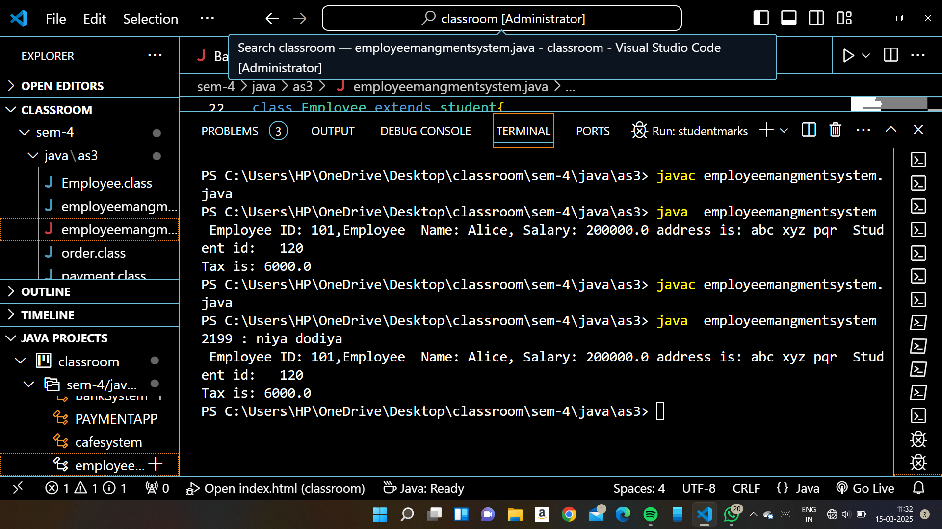

7.foodmanagment system

// multiplae inharitance with overriden interface method

interface foodservice{

    void preaparefood();

    void servefood();

}

class Restorent implements foodservice{

    protected String foodname;

    private double price;

    Restorent(String foodname,double price){

        this.foodname=foodname;

        this.price=price;

    }

     public void preaparefood(){

            System.out.println("The food is preaparing :"+foodname);

     }

     public void servefood(){

            System.out.println("the price of food is :"+price);

     }

}

class cateringservice implements foodservice{

    String eventname;

    int guestcount;

    cateringservice(String eventname,int guestcount){

        this.eventname=eventname;

        this.guestcount=guestcount;

    }

    public void preaparefood(){

            System.out.println("the food is preaparing for "+eventname+ "  this event");

    }

    public void servefood(){

            System.out.println("total no of guest is :"+guestcount);

    }

}

class restromanagment{

    public static void main(String[] args) {

        System.out.println("2199 : niya dodiya");

        Restorent r1=new Restorent("burger",223.8);

        r1.preaparefood();

        r1.servefood();

        cateringservice c1=new cateringservice("birthdayparty",250);

        c1.preaparefood();

        c1.servefood();

    }

}

